1. Objectives:

Our project name is Tic-Tac-Toe game. This game is very popular and is

fairly simple by itself. It is actually a two player game. In this game, there is

a board with n x n squares. In our game, it is 3 x 3 squares.

The goal of Tic-Tac-Toe is to be one of the players to get three same

symbols in a row - horizontally, vertically or diagonally - on a 3 x 3 grid.

1. Objectives:

Our project name is Tic-Tac-Toe game. This game is very popular and is

fairly simple by itself. It is actually a two player game. In this game, there is

a board with n x n squares. In our game, it is 3 x 3 squares.

The goal of Tic-Tac-Toe is to be one of the players to get three same

symbols in a row - horizontally, vertically or diagonally - on a 3 x 3 grid.

1. Objectives:

Our project name is Tic-Tac-Toe game. This game is very popular and is

fairly simple by itself. It is actually a two player game. In this game, there is

a board with n x n squares. In our game, it is 3 x 3 squares.

The goal of Tic-Tac-Toe is to be one of the players to get three same

symbols in a row - horizontally, vertically or diagonally - on a 3 x 3 grid.

1. Objectives:

Our project name is Tic-Tac-Toe game. This game is very popular and is

fairly simple by itself. It is actually a two player game. In this game, there is

a board with n x n squares. In our game, it is 3 x 3 squares.

The goal of Tic-Tac-Toe is to be one of the players to get three same

symbols in a row - horizontally, vertically or diagonally - on a 3 x 3 grid.

1. Objectives:

Our project name is Tic-Tac-Toe game. This game is very popular and is

fairly simple by itself. It is actually a two player game. In this game, there is

a board with n x n squares. In our game, it is 3 x 3 squares.

The goal of Tic-Tac-Toe is to be one of the players to get three same

symbols in a row - horizontally, vertically or diagonally - on a 3 x 3 grid.

1. Objectives:

Our project name is Tic-Tac-Toe game. This game is very popular and is

fairly simple by itself. It is actually a two player game. In this game, there is

a board with n x n squares. In our game, it is 3 x 3 squares.

The goal of Tic-Tac-Toe is to be one of the players to get three same

symbols in a row - horizontally, vertically or diagonally - on a 3 x 3 grid.

**Tic Tac Toe Game**

**SYNOPSIS**

SUBMITTEDINPARTIALFULFILLMENTOFTHEREQUIREMENTFORTHE AWARD OF THE DEGREE OF (12pt.)

# BACHELOROFTECHNOLOGY

(CSE)(3rd yr)

SUBMITTED BY

(Shivam Batham - 2100460109003)



# Dr.APJ Abdul Kalam Technical University ,UttarPradesh

# LUCKNOW , INDIA

2022-23

**OBJECTIVE**

My project name is Tic-Tac-Toe game. This game is very popular and is

fairly simple by itself. It is actually a two player game. In this game, there is

a board with n x n squares. In my game, it is 3 x 3 squares.

The goal of Tic-Tac-Toe is to be one of the players to get three same

symbols in a row - horizontally, vertically or diagonally - on a 3 x 3 grid.

Generally, The Tic-Tac-Toe game is based on having a game board (2D array) of size 3 x 3. The players alternate placing Xs and Os on the board until either one has placed three Xs or Os in a row horizontally, vertically, or diagonally; or all nine board squares are filled. The player wins if s/he draws three Xs or three Os in a row. Otherwise, the game is draw.

Initially the board grid squares are initialized to zeros. Xs and Os might be denoted by numbers

inside the board grid by ones and twos respectively. I.e. if player one choses X, the location of

that choice is registered as 1 and when player two choses O the location of that choice in your

array is registered as 2. At the end if a row of 1s is registered then player one won the game. Or if a row of 2s is registered thus player two won the game. If not, the game is draw. The game ends when there is no more empty fields in the array (board) to fill or if one of the players wins the game.

2. Overview:

This game can be played in a3x3 grid (shown in the figure 2.1) .The game

can be played by two players. There are two options for players:

(a) Human (b) Compute

**INTRODUCTION**

This game can be played in a 3x3 grid (shown in figure below) .The game

can be played by two players. There are two options for players:

Generally, The Tic-Tac-Toe game is based on having a game board (2D array) of size 3 x 3. The players alternate placing Xs and Os on the board until either one has placed three Xs or Os in a row horizontally, vertically, or diagonally; or all nine board squares are filled. The player wins if s/he draws three Xs or three Os in a row. Otherwise, the game is draw.

(a) Human

(b) Human

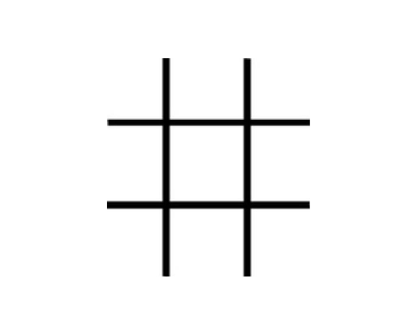

**SOFTWARE AND HARDWARE**

**REQUIREMENT**

**SOFTWARE REQUIREMENT**

1. Laptop
2. VS code studio IDE
3. VS Live server for local hosting
4. OS – windows
5. JavaScript
6. HTML
7. Cast cadding style sheet (CSS)

**HARDWARE REQUIREMENT**

1. Laptop
2. 256 GB SDD
3. Ryzen 3 processor
4. Intel UHD Graphic

2.1 Players:

For the option human, both the players are human and for the option

computer, the first player is human and the second player is computer.

**TECHNOLOGIES USED**

**Web - technology**

**HTML :** HTML is the standard markup language for Web pages. With HTML you can create your own Website. HTML is easy to learn and easy to use. It is platform-independent. Images, videos, and audio can be added to a web page. Hypertext can be added to the text. It is a markup language.

**CSS :** CSS is the language we use to style an HTML document.CSS describes how HTML elements should be displayed. CSS stands for Cascading Style Sheet.

**JavaScript :** JavaScript is the world's most popular programming language. JavaScript is easy to learn. JavaScript is the programming language of the Web. All popular web browsers support JavaScript as they provide built-in execution environments. JavaScript follows the syntax and structure of the C programming language. Thus, it is a structured programming language. It is a light-weighted and interpreted language. It is a case-sensitive language. JavaScript is supportable in several operating systems including, Windows, macOS, etc. It provides good control to the users over the web browsers.

**PROPOSED WORK**

**Players:**

Both the players are humans.

**Theory of Game:**

A player can choose between two symbols with his opponent, usual games

use “X”and “O”. If first player choose “X” then the second player have to

play with “O” and vice versa.

A player marks any of the 3x3 squares with his symbol (may be “X” or “O”)

and his aim is to create a straight line horizontally or vertically or diagonally

with two intensions:

a) Create a straight line before his opponent to win the game.

b) Restrict his opponent from creating a straight line first.

In case logically no one can create a straight line with his own symbol, the

game results a tie.

Hence there are only three possible results – a player wins, his opponent

(human or computer) wins or it’s a tie

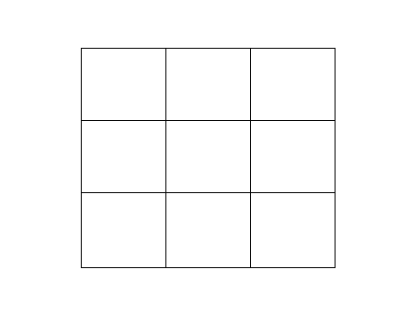

4 5 6   
7 8 9

1 2 3 21212221172 22

Figure.

If any player is able to draw three Xs or three Os in the following

combinations then that player wins.

**The combinations are:**

a) 1, 2, 3 b) 4, 5, 6

c) 7, 8, 9 d) 1, 4, 7

e) 2, 5, 8 f) 3, 6, 9

h) 1, 5, 9 i) 3, 5, 7

**Core Logic - Humans:**

For each move, check whether any 3 combination is occupied by any player

and display the winner accordingly.

**Limitations:**

Only mouse interface is implemented, keyboard is not activated in the

Game.

**Future plan:**

1. Keyboard functions will be added.

2. We want to design more complex boards for the game in future

**FLOW CHART**

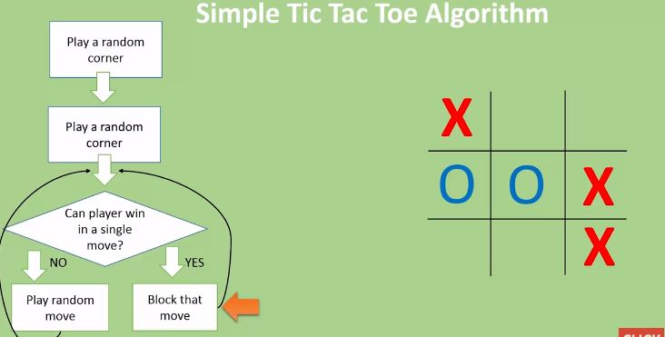

**CONCLUSION**

Conclusion **The Tic Tac Toe game is most familiar among all the age groups**. Intelligence can be a property of any purpose-driven decision maker. This basic idea has been suggested many times. An algorithm of playing Tic Tac Toe has been presented and tested that works in efficient way.

**Reference:**

W3school .com

CodeWithHerry.com